Raw Notes by Jolly Gupta
Came to know about Context7 via a Data Sense LinkedIn post and explored it on 16 April 2026.
Small steps initially matter the most. I move forward with curiosity and courage. In a world where versions constantly change, staying updated is essential—because even LLMs are limited by outdated knowledge.

Context7 Plugin in Claude: Why It Matters for AI Engineers
Context7 - Up-to-date documentation for LLMs and AI code editors
Context7 is how I get latest knowledge before coding
In tools like Claude, one major limitation of LLMs is outdated knowledge. Models are trained on past data, so they may not know the latest APIs, libraries, or updates.
This is where Context7 plugin becomes powerful.
What is Context7 Plugin?
Context7 is a documentation retrieval plugin that allows Claude to:
👉 Fetch latest official docs
👉 Pull real-time API references
👉 Inject them as context before generating answers
Think of it as:
“Live documentation layer added to Claude”
How It Works (Simple Flow)
- User asks a question
→ “How to use latest OpenAI API?”
- Context7 plugin
→ fetches latest documentation
- Claude
→ uses that fresh context to generate answer
Why It’s Important
1. Solves Outdated Knowledge Problem
LLMs have a cutoff date
Context7 → brings up-to-date info
2. Improves Code Accuracy

Without Context7:
❌ Deprecated functions
❌ Wrong syntax
With Context7:
✅ Latest methods
✅ Correct usage
3. Powerful for Developers
For AI engineers working with:
- APIs
- SDKs
- frameworks
Context7 ensures:
👉 You are always aligned with current documentation
Relation with RAG
Context7 is basically a real-world implementation of Retrieval-Augmented Generation
Difference:
- RAG → you fetch your own data
- Context7 → fetches official docs automatically
Real Insight

Without Context7:
AI = knowledgeable but outdated
With Context7:
AI = knowledgeable + current + reliable

Context7 actually works in BOTH places — they're two separate integrations:
1. Claude.ai chat (web/app) — as a plugin/connector You connect it directly on claude.ai (Tools menu → Context7 → Connect). Once connected, you just type use context7 in any chat message. No installation needed. This is what I showed in the guide above.
2. Code editors (Cursor, VS Code, etc.) — as an MCP server This requires the CLI setup and runs locally alongside your editor. Claude Code (the terminal tool) also uses this path.
CLI = Command Line Interface
It’s a way to interact with your computer or tools by typing commands instead of clicking buttons (GUI).
On your simplified flow — one correction needed:
The command npx ctx7 setup is not the real command. That package doesn't exist. The actual commands from official sources are:
Complete steps from scratch — Claude Code setup:
Press: Windows key + R Type: cmd Hit: Enter
Step 1 — Download & Install Node.js 18+

For Beginners
Go to: https://nodejs.org
Download: LTS version (18+ or 20+ recommended)
Run the installer → click Next → Next → Install
For Developers:
winget install OpenJS.NodeJS.LTS

Step 2 — Verify installation
bash
node -v # Should show v18.x.x or higher→ Node is installed, you're ready for next step.
npm -v # Should show a version number too
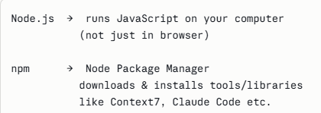
Step 3 — Install Claude Code
npm install -g @anthropic-ai/claude-code
Step 4 — Verify Claude Code
claude --version
Step 5 — Add Context7 MCP
claude mcp add context7 -- npx -y @upstash/context7-mcp@latest
Context7 works via:
- MCP (Model Context Protocol)
- not a simple npm package like “ctx7”

Step 6 — Restart Claude Code
exit
claude
Step 7 — Verify Context7 is connected
claude mcp list
# Should show "context7" in the list
Step 8 — Test it
"How do I create a middleware in Next.js? use context7"
If Context7 fetches live docs before answering → working perfectly.
Common issues:
- node -v not found → restart terminal after installing Node
- claude not found → restart terminal after npm install -g
- Rate limited → get free API key at context7.com/dashboard
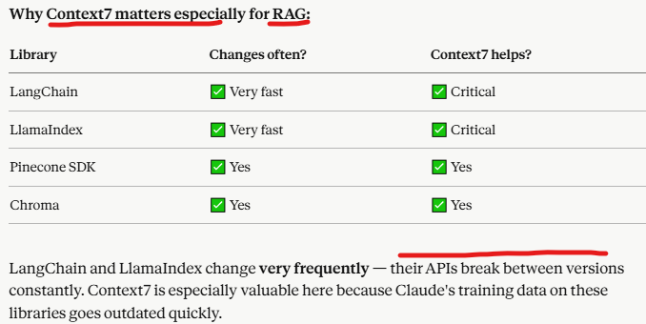
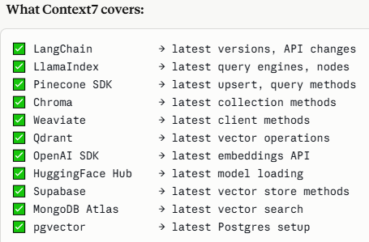
Context7 enhances RAG by adding a live retrieval layer that fetches up-to-date external data, improving accuracy, freshness, and reducing hallucinations.
Context7 → get latest docs/snippets
↓
Claude.ai / CLI → generate correct code (using those docs)
↓
Google Colab → run + test code
↓
(optional) enhance with live retrieval / improvements
✅ Step 0: Give Prompt
👉 Output = latest, correct code
✅ Step 1: Copy Generated Code
👉 From Claude / CLI
✅ Step 2: Paste in Google Colab
✅ Step 3: Install Dependencies
pip install -U langchain langchain-community langchain-openai chromadb
✅ Step 4: Run Pipeline
👉 Load → Split → Embed → Store → Retrieve → LLM
✅ Step 5: (Optional) Add Context7-style Live Retrieval
docs_db = vectorstore.similarity_search(query)
docs_live = fetch_live_docs(query)
final_docs = docs_db + docs_live
Your Final Mental Model
Step 0 → Get latest code using Context7 prompt (teacher gives correct notes 📘)
Step 1–4 → Build & run RAG (you study & write exam ✍️)
Step 5 → Enhance with live data (you use internet for extra info 🌐)

Prompt in claude.ai
Method 1: Let the LLM Handle It (Best for you now)
Use latest LangChain documentation (Context7 style).
Build a RAG pipeline.
IMPORTANT:
- Use latest imports (langchain_community, langchain_openai)
- Avoid deprecated code
- If anything is outdated, automatically replace it

Also explain what changed from older versions. this is prompt for claud.ai but what for CLI?
Prompt in CLI:
Method 1: Prompt
Same Prompt Works in CLI Too
Method 2: One-Line Command (Pro Way)
claude "Use latest LangChain documentation (Context7 style). Build a RAG pipeline using latest imports and avoid deprecated code."
Complete Prompt:
Use the latest official documentation (Context7 style) to build a production-ready RAG pipeline.
Requirements:
Framework:
- Use latest LangChain (v0.2+ or newer)
- Also show equivalent pipeline using LlamaIndex (latest version)
Data Ingestion:
- Use modern document loaders (web, PDF, text)
- Explain when to use each loader

Chunking:
- Use RecursiveCharacterTextSplitter (latest)
- Explain chunk_size, overlap, and best practices

Embeddings:
- Use latest OpenAI embeddings (langchain_openai)
- Also mention HuggingFace embeddings as alternative
- Explain when to use which

Vector Database:
- Use Chroma (local)
- Also explain Pinecone / Weaviate / Qdrant (when to use each)
- Use latest APIs only

Retrieval:
- Use retriever (similarity search)
- Also implement advanced retrieval:
- MMR (Max Marginal Relevance)
- Top-k tuning

LLM:
- Use ChatOpenAI (latest)
- Show how context is injected into prompt

Pipeline:
- Build complete flow:
Load → Split → Embed → Store → Retrieve → Generate

Code Requirements:
- Fully runnable in Google Colab
- Include pip install commands
- Use latest imports:
- langchain_community
- langchain_openai
- langchain_core
- Avoid deprecated code completely

Advanced (IMPORTANT):
- Add Context7-style live retrieval (optional layer)
- Show how to combine:
vector DB results + live docs

Output:
- Clean, modular Python code
- Step-by-step explanation
- Highlight what changed from older LangChain versions

Bonus:
- Mention common errors and how to fix them
Make the code production-ready and beginner-friendly.

RAG-related prompts with Context7 — examples:
Basic RAG setup:
How do I build a RAG pipeline using LangChain? use context7
After using Context7:
- Copy generated code
- Paste in Colab
- Install dependencies
- Run pipeline
- (Optional) Add live retrieval for better results
Note: same steps with other individual prompts
Vector database specific:
How do I store embeddings in Pinecone for RAG? use context7
How do I use Chroma as a vector store in RAG? use context7
How do I set up Weaviate for document retrieval? use context7
Embedding models:
How do I generate embeddings using OpenAI in a RAG app? use context7
How do I use HuggingFace sentence transformers for RAG? use context7
Chunking & document loading:
How do I split and chunk documents in LangChain for RAG? use context7
How do I load PDFs into a RAG pipeline using LlamaIndex? use context7
LlamaIndex specific:
How do I build a RAG query engine using LlamaIndex? use context7
How do I set up a vector index in LlamaIndex v0.10? use context7
Full pipeline questions:
Build me a RAG pipeline using LangChain + Pinecone + OpenAI embeddings. use context7

How Many Engineers Use Context7? (Reality)
1. GitHub Popularity (Strong Signal)
- Context7 MCP repo has ~25,000+ stars
👉 In developer world:
⭐ 1K = small tool ⭐ 10K+ = widely adopted ⭐ 25K+ = very popular
2. Ecosystem Adoption
Context7 is:
- used in AI tools like Cursor, Claude Code, VS Code integrations
- integrated into developer workflows (IDE + AI coding tools)
👉 Meaning:
Thousands of engineers are actively using it
3. Scale of Documentation Coverage
- Supports 30,000+ libraries
- Covers many frameworks + languages
👉 This only happens when:
- many developers rely on it
Realistic Estimate (Honest Answer)
No official count, but based on data:
🧑‍💻 Thousands to tens of thousands of engineers
📈 Rapidly growing (especially in AI/GenAI space)

